Proposal to Implement a Trello Based Work Management System for Improved Coordination and Productivity In CEC Laboratory

Materials Science and Engineering Trainee
Consulting Engineering and Contractors
Date: 22/01/2025
Introduction
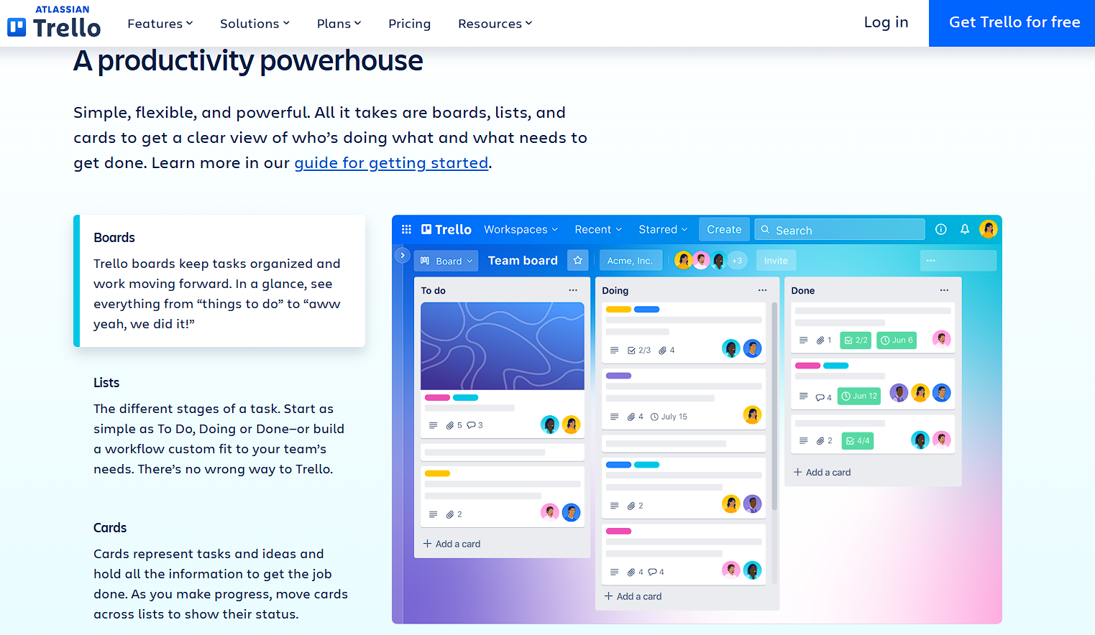
The efficiency of the laboratory at Consulting Engineering and Contractors is hindered by the absence of a structured daily work planning system. While the project office effectively uses a whiteboard to manage daily tasks, replicating this in the laboratory is impractical due to costs and scalability challenges. To address this, a modern Trello-based work management system is proposed.
Figure :Trello login page in windows
Trello is a user-friendly, cost-effective application that integrates seamlessly into workflows, making it ideal for laboratory operations. This system will streamline task assignments, enhance communication, and foster accountability, leveraging the technical expertise of trainers, material engineers, and technicians. By adopting Trello, the laboratory can address inefficiencies, improve productivity, and create a collaborative work environment. This proposal details a practical and scalable implementation plan to make Trello the foundation of daily management in the laboratory.

Problem Statement
The laboratory currently lacks a formal system for communicating daily tasks and targets. Unlike the project office, which utilizes a whiteboard for planning, laboratory employees do not have a shared understanding of daily objectives. This results in:
- Poor utilization of time and resources.
- Misalignment of efforts with organizational goals.
- Decreased employee morale due to uncertainty.
- Potential redundancy or overlap in tasks.
This managerial gap has a direct impact on laboratory productivity and project timelines, necessitating a structured approach to daily work planning.

Objectives
This proposal aims to:
- Introduce a daily work planning and target-setting system in the laboratory.
- Ensure all laboratory employees understand their tasks and responsibilities.
- Foster better coordination and communication among laboratory team members.
- Improve overall efficiency and productivity in the laboratory.

Proposed Solution
To address this managerial challenge, the following solutions are proposed:
- Trello for Trainers and Material Engineers:
  - Utilize Trello, a user-friendly and free task management tool, to assign and track daily tasks for trainers and material engineers in the laboratory. As technically proficient team members, they can easily adopt and maintain this system.
- Whiteboard for Lab Helpers and Technicians:
  - Introduce a physical whiteboard in the laboratory to outline daily tasks and targets for lab helpers and technicians. This approach mirrors the successful system implemented in the project office, ensuring consistency and accessibility.
- Daily Morning Meetings:
  - Conduct a 10 – 15 minute meeting each morning in the laboratory to review the daily work plan, set targets, and address any immediate concerns.
- Progress Tracking:
  - Implement a system to review the progress of tasks at the end of each day, identifying any delays or areas for improvement.
- Feedback Mechanism:
  - Encourage laboratory employees to provide feedback on the work planning process, fostering continuous improvement and adaptability.

Expected Benefits
- Increased clarity and focus for all laboratory team members.
- Enhanced coordination and collaboration within the laboratory.
- Improved utilization of time and resources.
- Alignment of daily tasks with broader organizational goals.
- Higher employee satisfaction and motivation.

Implementation Timeline
- Week 1: Analyze existing workflows in the laboratory and gather input from employees.
- Week 2: Develop the work planning system, including setting up Trello and preparing a whiteboard for the laboratory.
- Week 3: Pilot the system within the laboratory to test its effectiveness.
- Week 4: Evaluate feedback from the pilot and refine the system as needed.
- Week 5: Fully implement the system in the laboratory and provide necessary training.

Resources Required
- Free Trello accounts for trainers and material engineers.
- A physical whiteboard and markers for lab helpers and technicians.
- Time allocation for daily morning meetings.
- Minimal training sessions to familiarize laboratory employees with the new systems.

Conclusion
Extending the structured daily work plan and target-setting system from the project office to the laboratory is essential to address current inefficiencies. By leveraging Trello for trainers and material engineers and introducing a whiteboard system for lab helpers and technicians, this proposal ensures clarity, better coordination, and enhanced productivity in the laboratory. With clear implementation steps and minimal resource requirements, this solution is practical, efficient, and impactful.

Approval Request
I seek approval to proceed with implementing the proposed solution in the laboratory. Your feedback and suggestions are highly valued to refine and enhance the effectiveness of this initiative.

